DATABASE MANAGEMENT SYSTEMS (10211CS207)

# TASK:12

**VEHICLE SERVICE ,MAINTAINENCE AND TRACKER**

|  |  |
| --- | --- |
| **Team Details:** |  |
| **Team members:** |
| R.VENKATA KARTHIK | VTU29180 |
| N.VENKATA YOGANADH | VTU29183 |
| M.HEMA HARSHITHA | VTU29208 |
| L.VUDHVI SAI | VTU29280 |
| N.VISHNU VARDHAN | VTU29355 |
| SK.VAHEED BASHA | VTU29379 |

**AIM:**

To develop a microproject on Vehicle Service Maintainence and Tracker System.

1. **ER Diagram:**

**AIM**:

To implement a conceptual design through FTR for Vehicle Service Maintainence and Tracker System.

**PROCEDURE:**

**Identifying entites:**

* 1. VEHICLE
  2. OWNER
  3. SERVICE_RECORD
  4. MAINTENANCE

**Identifying attributes:**

**VEHICLE**-Owner_ID,Name,Email,Phone_Number,Address,City,State,Registration_Date **OWNER**: Owner_ID, First_Name, Last_Name, Email, Phone_Number,

**SERVICE_RECORD**: Service_ID, Vehicle_ID, Service_Date, Service_Type, Mileage_At_Service, Next_Service_Date, Next_Service_Mileage, Total_Cost, Mechanic_ID, Status

**MAINTENANCE**: Maintenance_ID, Vehicle_ID, Maintenance_Type, Scheduled_Date, Completion_Date, Service_Provider, Cost, Status

**Identifying relationships:**

* + - OWNER to VEHICLE
    - VEHICLE to SERVICE_RECORD
    - VEHICLE to MAINTENANCE
    - SERVICE_RECORD to MAINTENANCE

**Identifying the cardinality:**

* + - OWNER (1) — (M) VEHICLE
    - VEHICLE (1) — (M) SERVICE_RECORD
    - VEHICLE (1) — (M) MAINTENANCE
    - SERVICE_RECORD (1) — (0..M) MAINTENANCE

**ER DIAGRAM:**

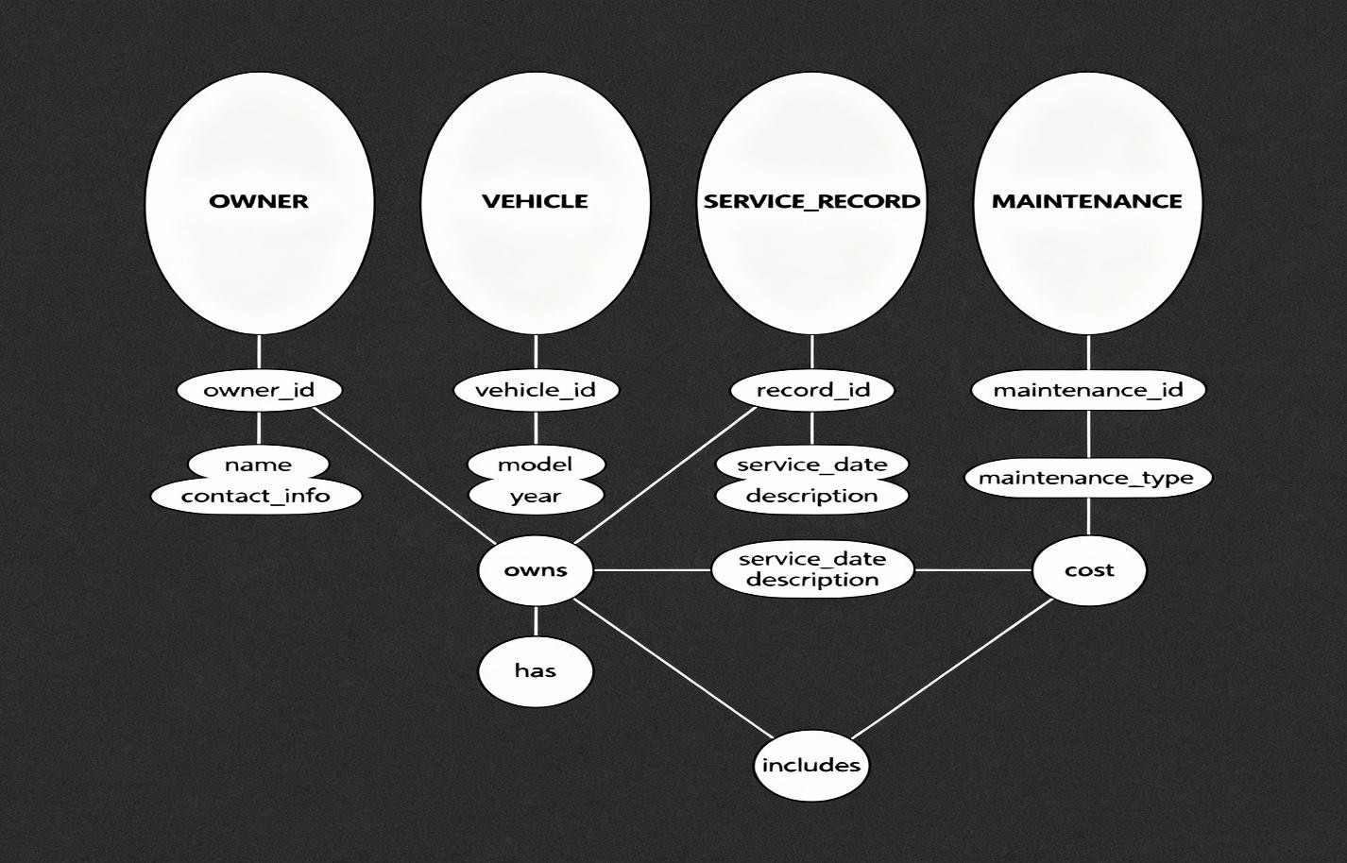

**Result:** Implementation of conceptual design through FTR for Vehicle Service Maintainence and Tracker System is successfully executed.

**02. SQL Queries & Relational operations:**

**Aim**: To execute relational operationms ,sql,aggregate,join &nested queries for Vehicle Service Maintainence and Tracker System.

**DDL commands:**

1. **create :**

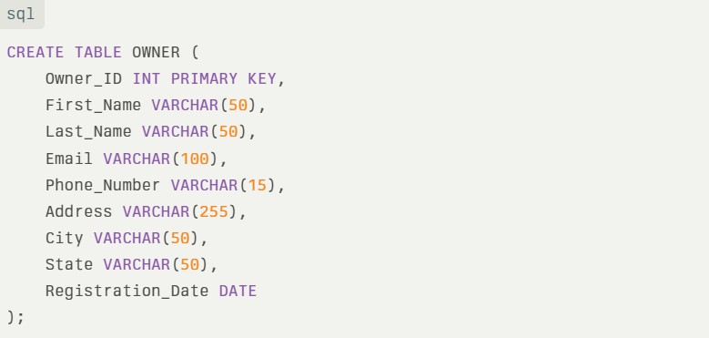

1. **alter:**

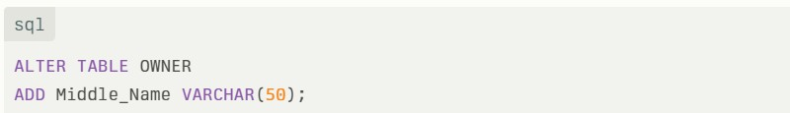

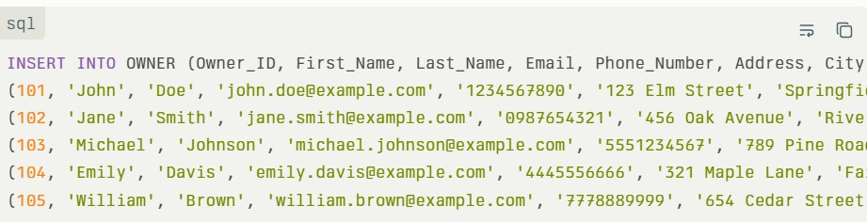**DML commands: 1.insert:**

1. **update:**

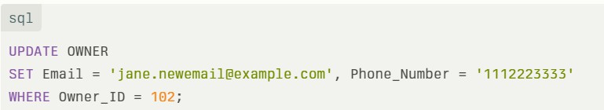

1. **delete:**

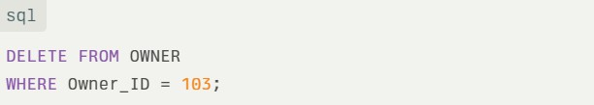

**DQL commands:**

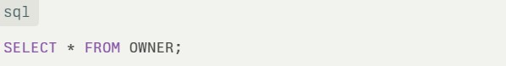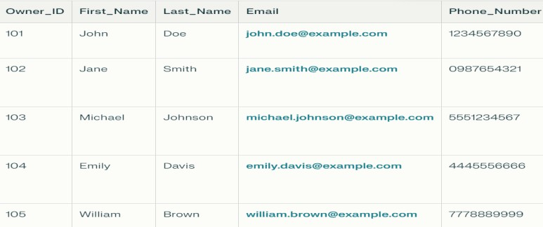

**DCL Commands:**

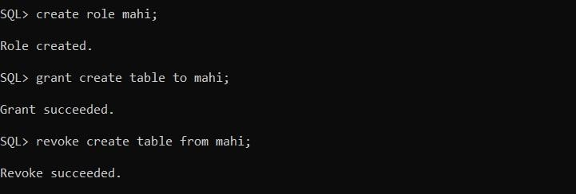

**DML single row functions and operators:**

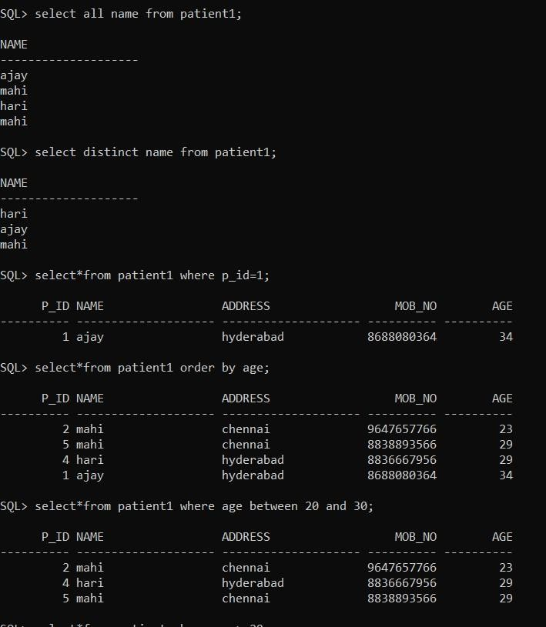

**Aggregate functions:**

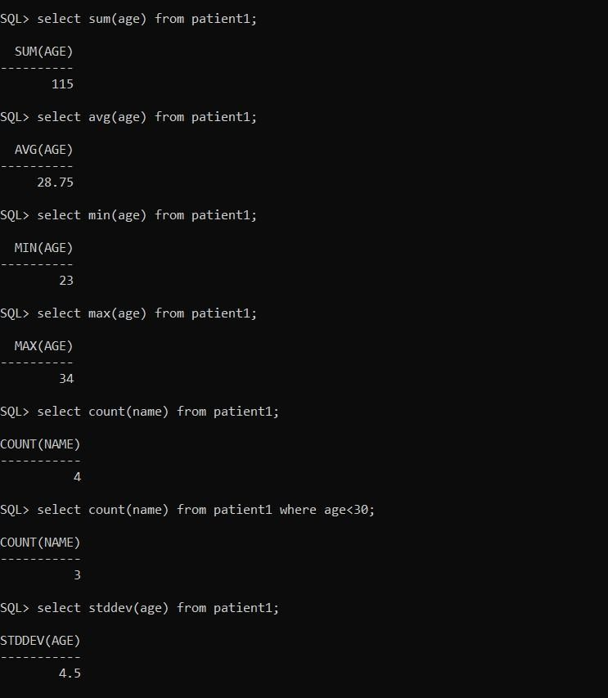

**Mathematical functions:**

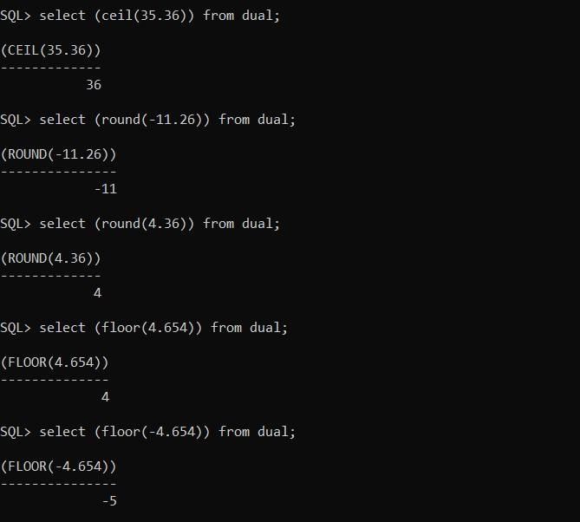

**String functions:**

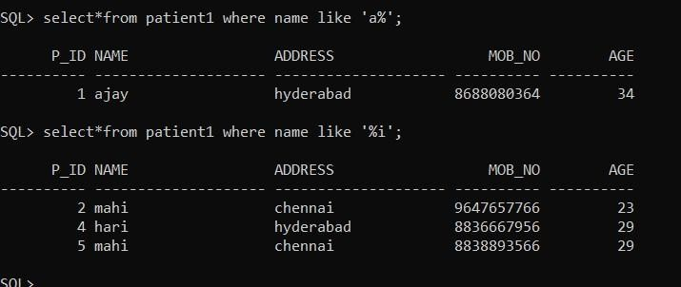

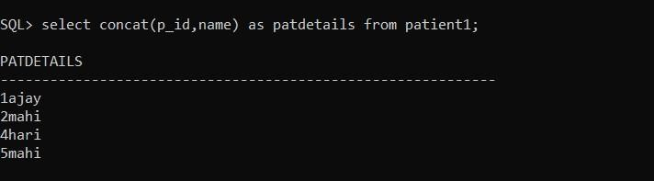

**SQL Joins:**

1. **right join:**

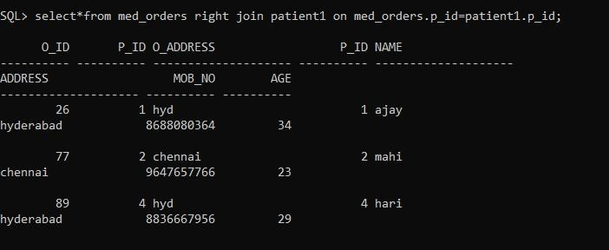

1. **left join:**

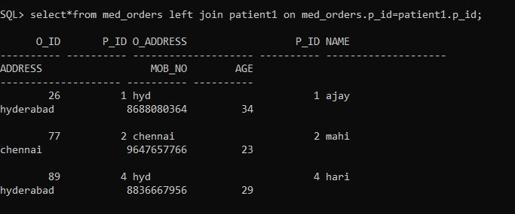

1. **cross join:**

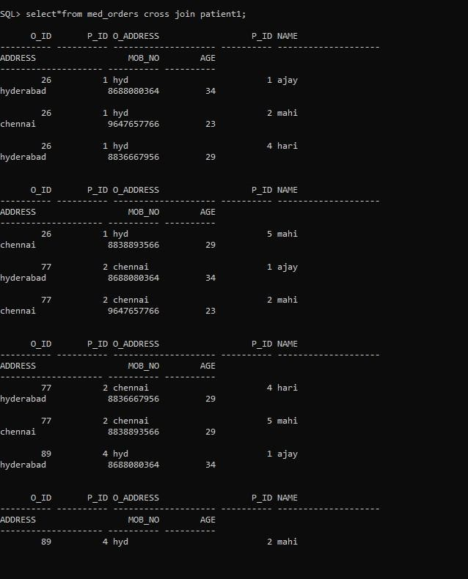

1. **inner join:**

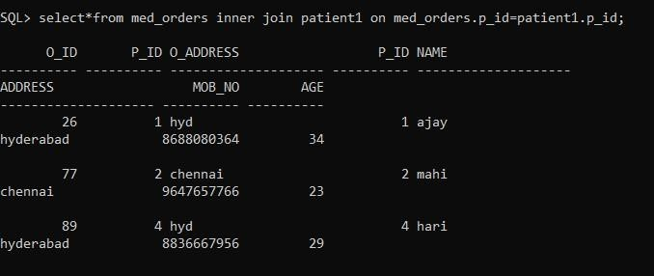

# PL/SQL

**Procedure:**

**Sample program for printing a sentence:**

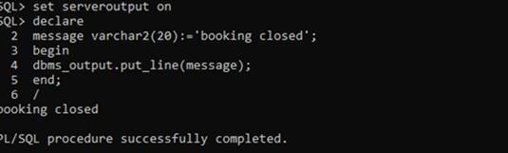

**Static input:**

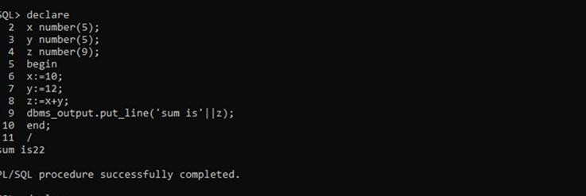

**Dynamic input:**

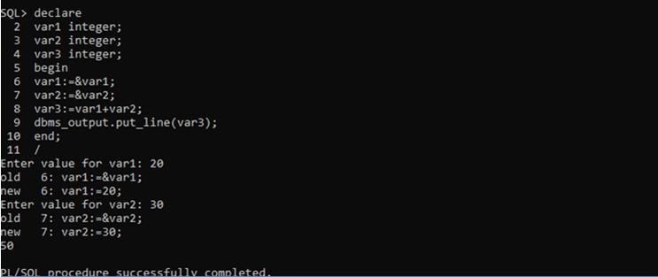

**Sample program for loops:**

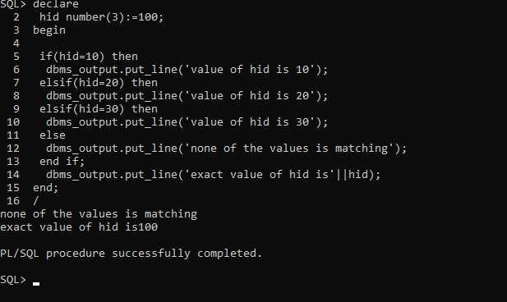

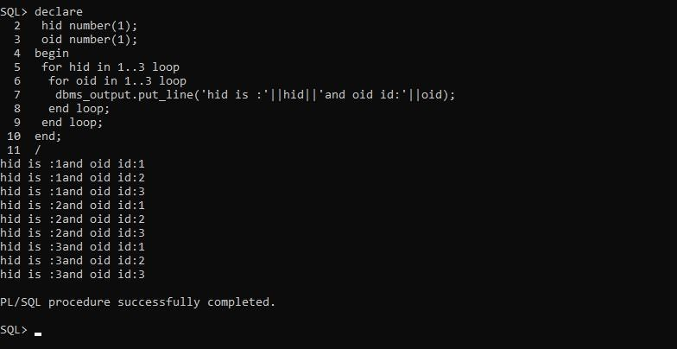

**Sample program for only procedure:**

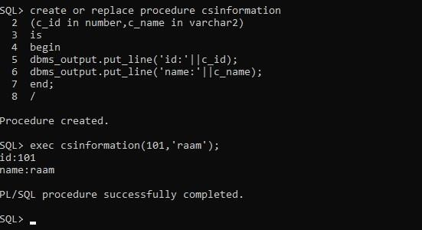

**Sample program for only function:**

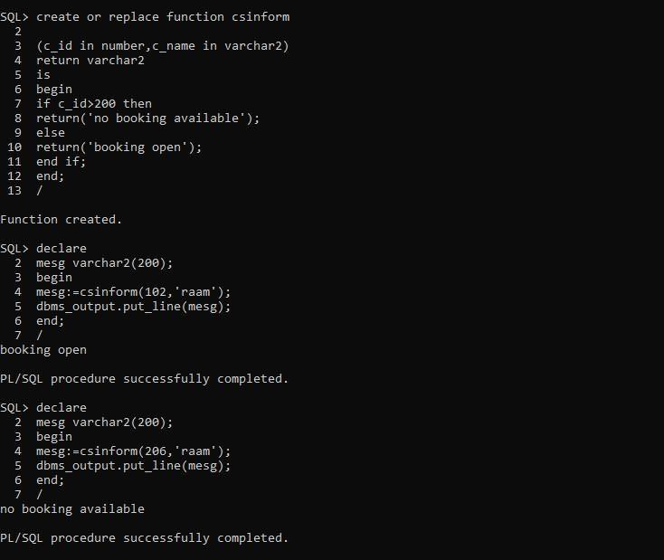

**to check the given customer booking number is Armstrong**

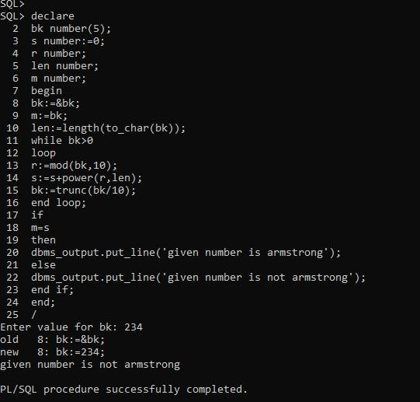

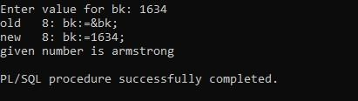

**Result**: thus the execution of the relational operations,sql aggregates,joint&nested queries are successfully executed.

## Normalisation:

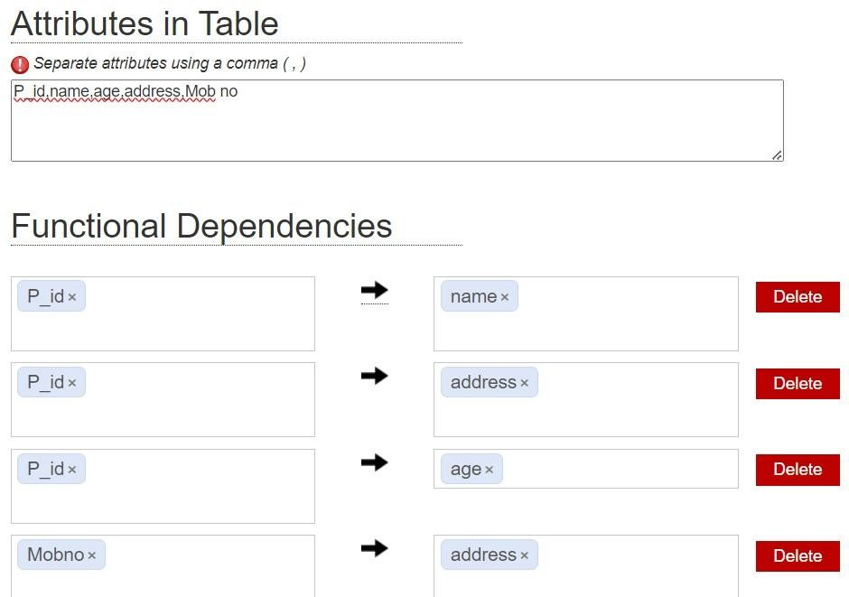**Aim: to** execute the normalisation forms for 1NF,2NF 3NF BCNF using Griffith tool **Attributes and functional dependencies:**

**Minimal cover:**

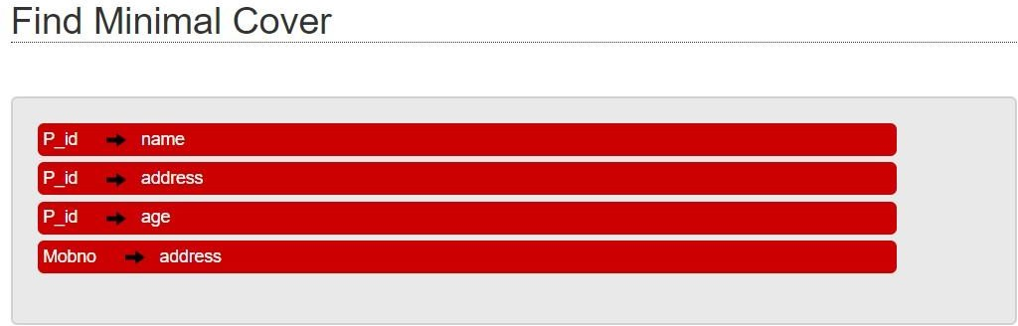

**Candidate keys:**

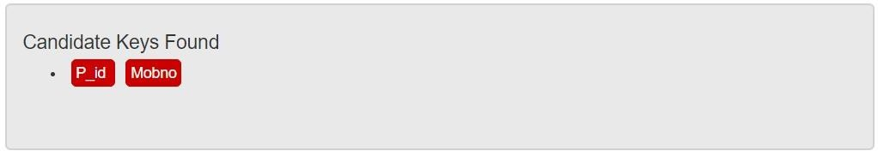

**Normal form:**

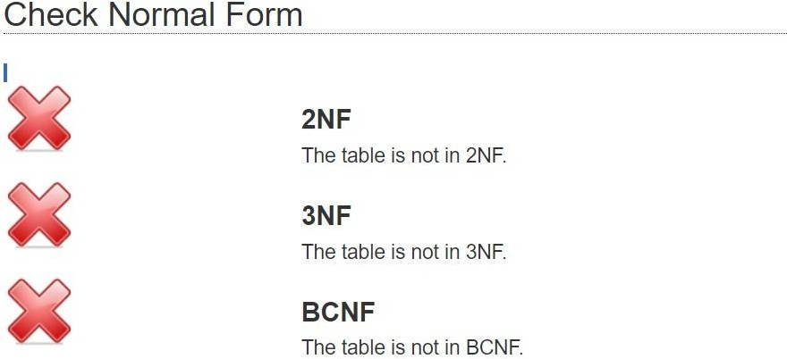

**2NF:**

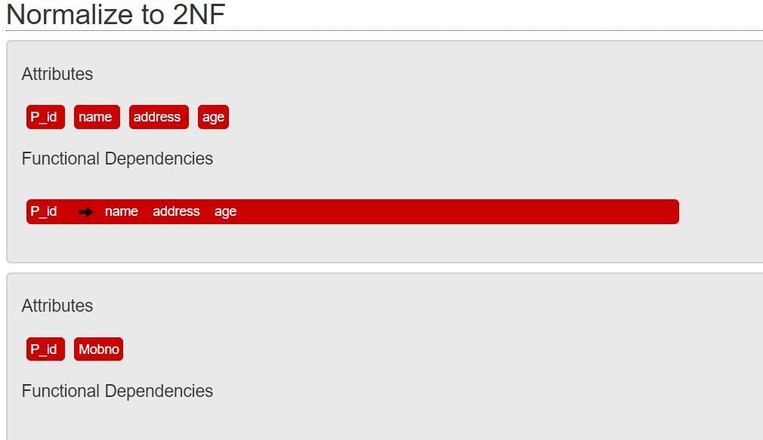

**3NF:**

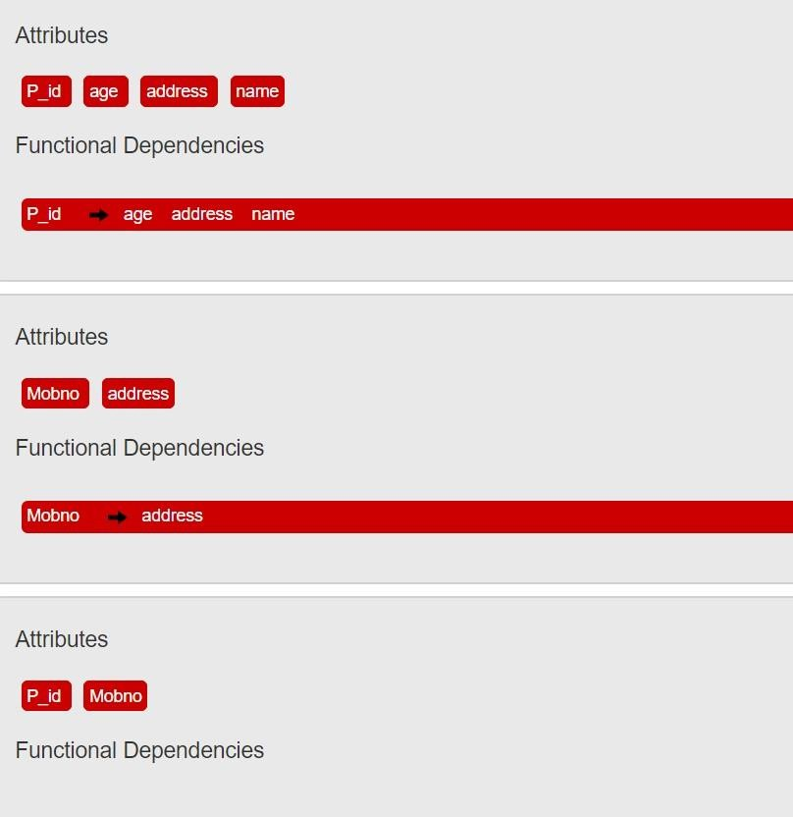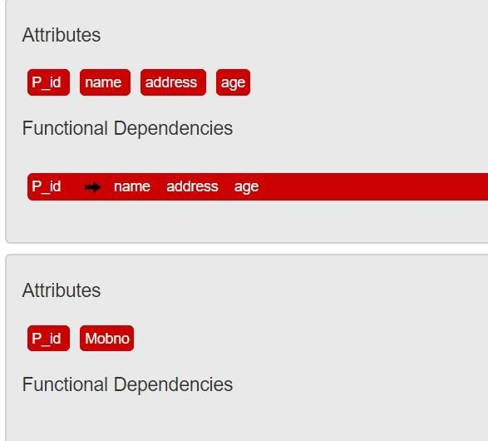

**BCNF:**

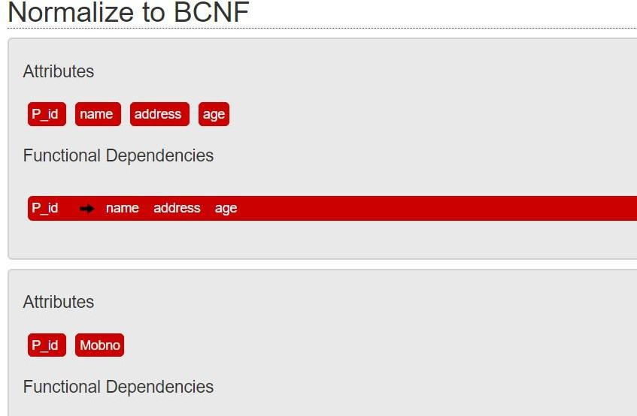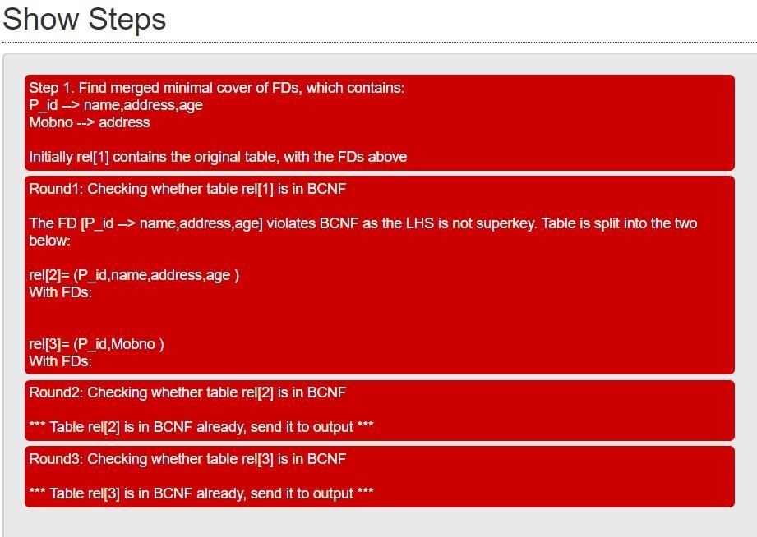

**Result:** Thus the normalisation to 1NF,2NF,3NF,BCNF is completed successfully

## mangoDB

**Aim**: To implement the document database by using mangosh **Create:**

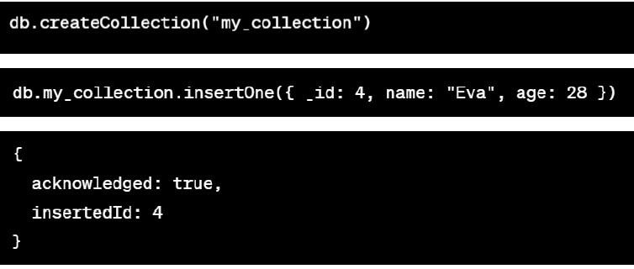

**Read:**

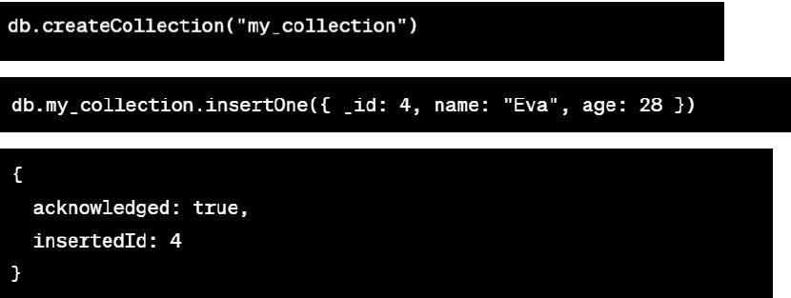

**Update:**

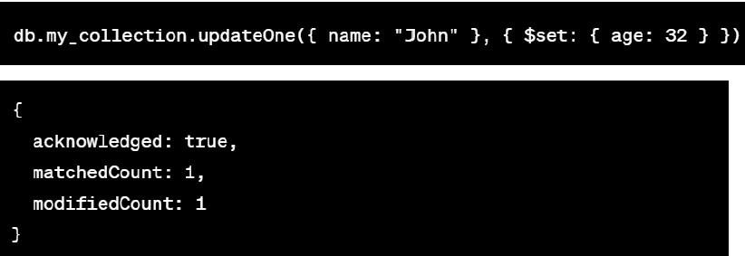

**Delete:**

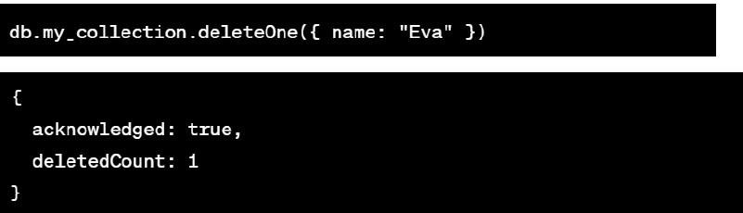

**Result:**

Thus CRUD using NPM design on MongoDB designing document database and performing CRUD operations like creating, inserting, querying, finding, removing operations are

performed

## graph database

**Create:**

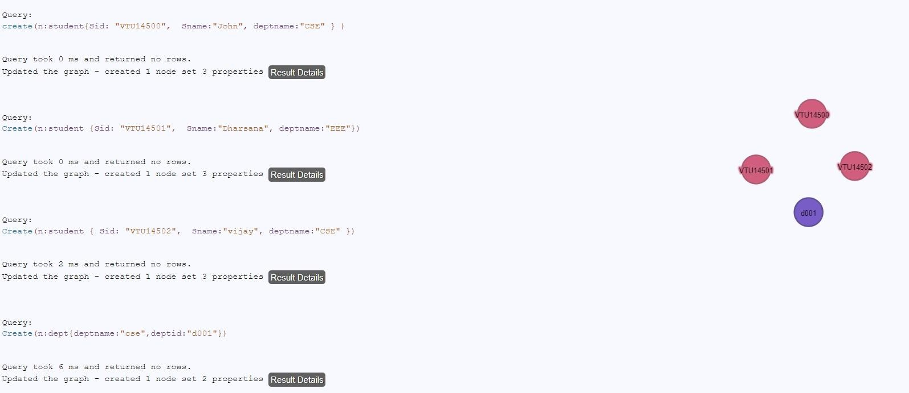

**Relate:**

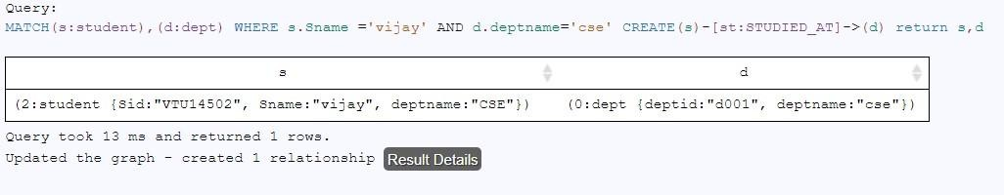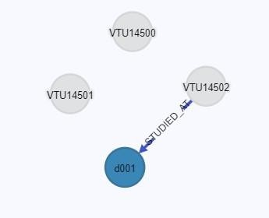

**Delete:**

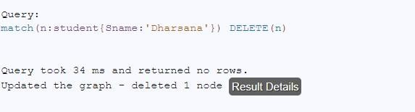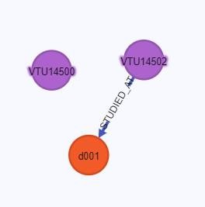

**Result:**

Thus the implementation of CRUD operations in graph spaces is completed successfully.

**Result:** thus micro project for Vehicle Service,Maintainence and Tracking System was developed and implemented successfully.